Attica Veterinary Associates
116 Prospect Street, Attica, NY 14011
585-591-2660 / fax 585-591-2898 / Text line 585-356-3420
www.atticacows.com
Newsletter – September 2023

An Introduction to Sensitivity Analysis for the Agribusiness Decision-Maker
By: Benjamin Luksic, VMD, MBA
Due to the highly variable nature of both biology and market conditions, the world of agriculture is increasingly complex. With constant volatility in price fluctuations, quantities of product produced, an animal’s feed intake, or costs, how can the modern manager make sense of all the moving pieces? One tool for making a calculated decision in the midst of uncertainty is sensitivity analysis. What is a sensitivity analysis? A sensitivity analysis allows the manager to see the simultaneous change in an output variable as one or more input variables might change across a range of possible values. Practical applications might include assessing the following:
- Uncertain prices. Evaluating how your milk revenue varies based on your cow numbers and milk prices. Output = milk revenue. Inputs = cow #’s, milk prices.
- Uncertain margins. Determining how your Income-Over-Feed-Cost varies based on milk revenue and feed cost. Output = IOFC. Inputs = milk revenue, feed cost.
- Uncertain costs. Assessing how the total cost of a disease outbreak might change based on individual treatment costs and possible disease incidence. Output = total cost of outbreak. Inputs = treatment costs, disease incidence.
- Uncertain production quantities. Assessing how acreage yields vary according to tons of fertilizer applied and acres planted. Output = yield. Inputs = fertilizer applied, acres planted.
- Uncertain sales. Assessing the profits on shipping silage based on the tons of silage shipped given several market prices. Output = profit. Input = tons of silage, market prices.
All of these are ways to evaluate and cope with risk. Because the user can simultaneously view the range of possible values, more informed decisions can be made than by simply relying on an average (a mean), a value occurring most frequently (a mode), or a “hunch”. Risk assessment instead becomes a game of probability based on calculated estimates rather than a guessing game of blatant uncertainty.
EXAMPLE:
Suppose you currently milk a herd of 800 Holsteins. This year, Dr. Keith was overexuberant at the county fair. Last week, he had rigged up a leaf blower with confetti to spray at all the winning 4-H-ers and their cows. He was last seen blowing confetti through the cow herds at the county fair.... starting with the winning cow, which you notice had the sniffles. Some of your animals had been shown at that very fair, down range of Dr. Keith and the winning cow. Now your herd has an outbreak of pneumonia.
In the past week since the fair you have lost 15 animals and estimate another 13 are coughing. You had Dr. Scott necropsy the second animal that died, and know he was thorough because he stoically pulled his posting knife from the carcass the same way he pulled his transducer from your last cow at the end of herd check.... the same way that King Arthur pulled his sword from the stone. You now have culture results and are treating the 13 remaining affected animals with an effective antibiotic. You are busy budgeting for other projects and want to determine the total possible treatment cost of the outbreak given an uncertain drug price and an uncertain rate of infection. Assuming it takes you one week longer to cure the infection, you decide to model this scenario in Excel below.

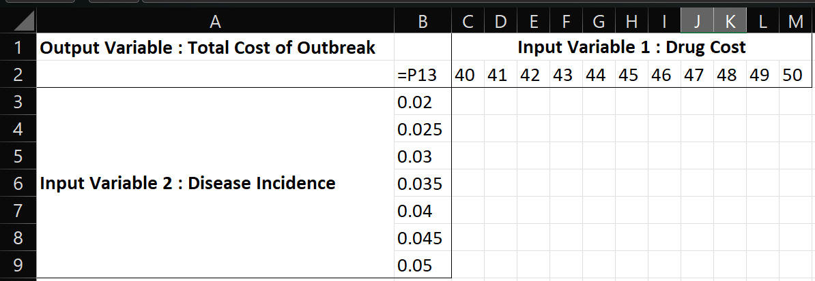
Setting up a Base Model:
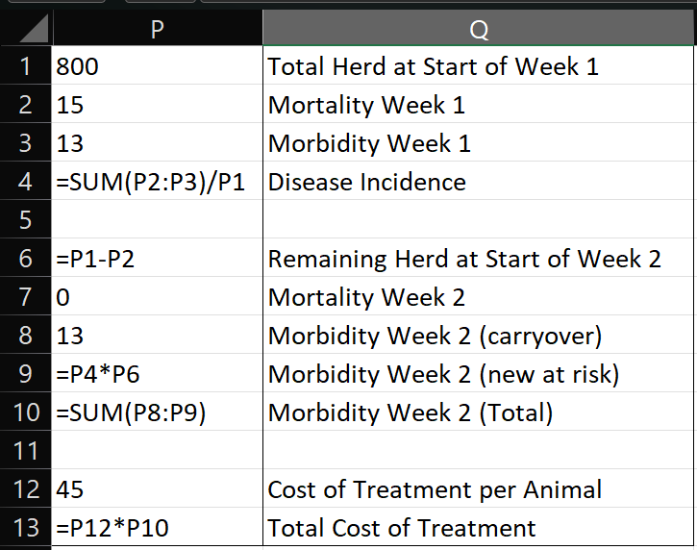
Setting up the Data Table:

To make the data table, select the only the numbered range B2:M9. Select “Data” on the Ribbon > What If Analysis > Data Table
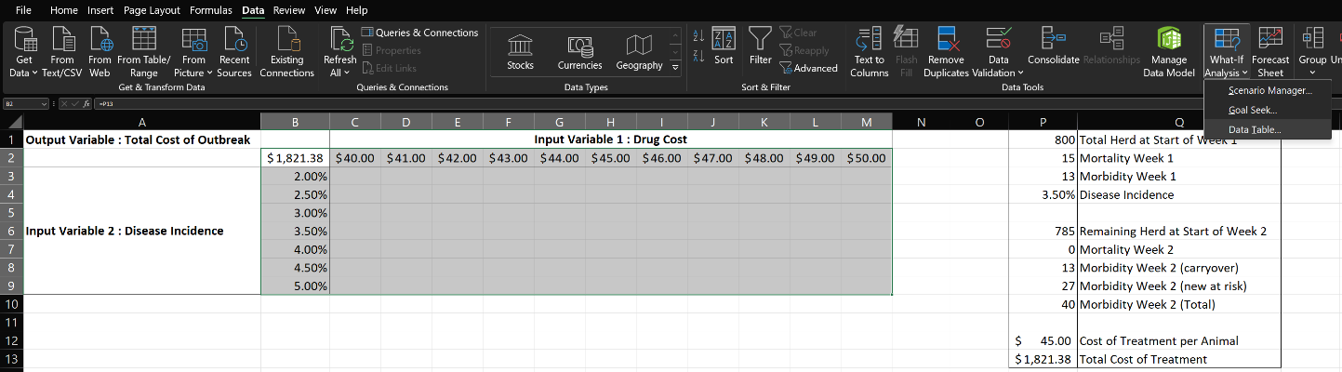
For the Row Input, select input variable 1: Drug Cost
For the Column Input, select input variable 2: Disease Incidence
Here, you are asking Excel to plug in each of the row 2 price cells in the data table for the ‘’Cost of Treatment per Animal” cell (P12) in the model, and plug in each of the column B disease incidence cells in the data table for the “Disease Incidence” cell (P4) in the model.
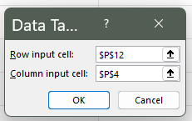
Click OK and View the Sensitivity Table. Note that the units in this example don’t particularly matter. Any other sensitivity table would be set up in much the same way.
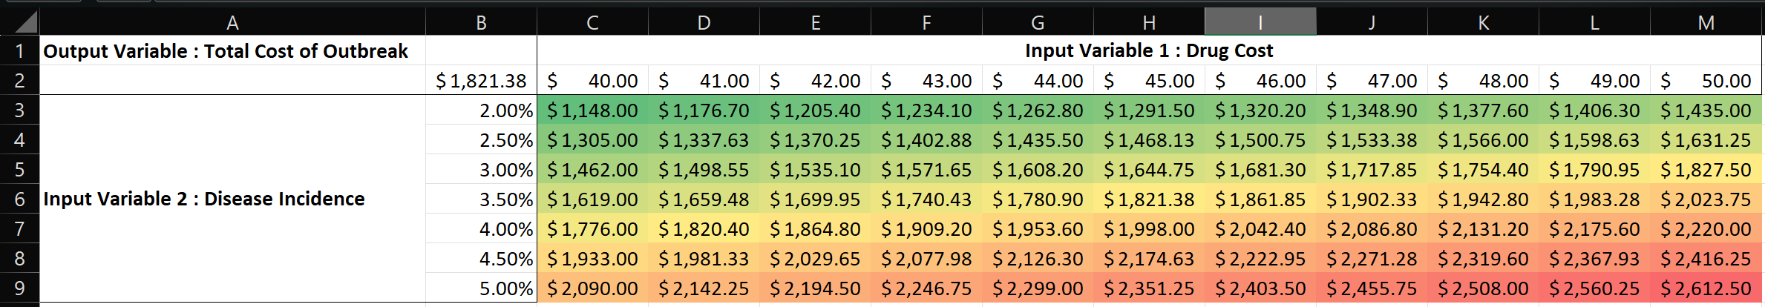
Based on this analysis, you recognize that curing the disease by next week at the current rate of 3.5% incidence may be too optimistic. Furthermore, the drug manufacturer announces an increase in their antibiotic premiums! Although unsure of your exact cost, you estimate that it will increase to about $49/treatment and that incidence over the next week will increase to 4.5%. From the table, you ask Dr. Keith to reimburse you $2367.93 for ongoing treatment costs in addition to the cost of the 15 lost animals for his leaf blowing expedition, which he pays... forfeiting next year’s AttiCow 50000 Double-Barrel Banana Clip Leafblower upgrade.
While you hope this ridiculous nonsense never happens again, you begin to ponder other uses for a sensitivity analysis in running your business, knowing that the Attica Vets are always willing to help answer your questions.

